**TUGAS PERTEMUAN 7**

Nama : Martin Caesar Partogi

NPM : 242310034

Kelas : TI-24-PA2

**Screenshoot OUTPUT halaman 119 nomor 1**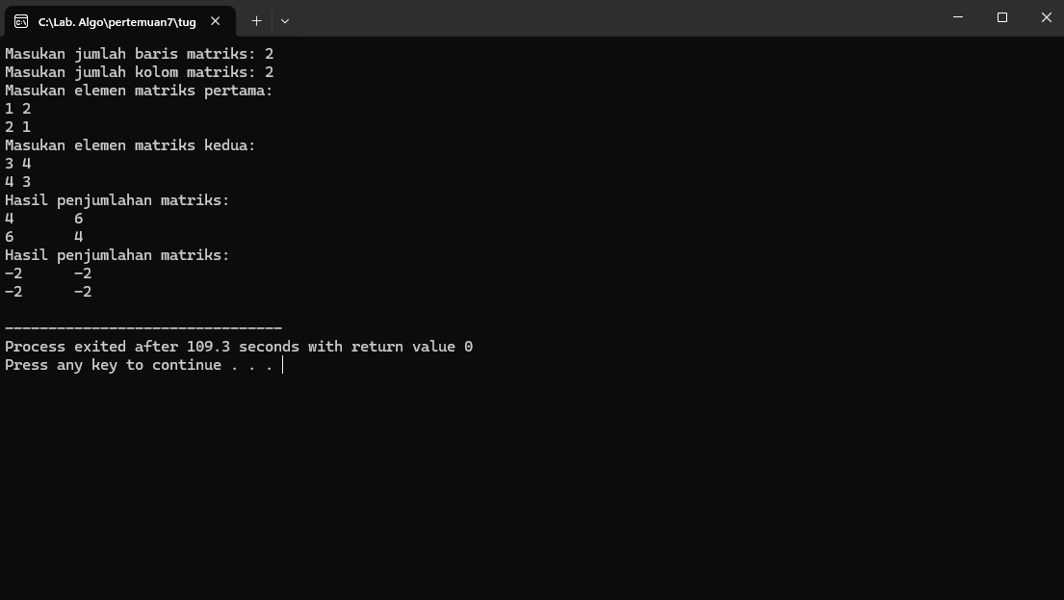

**Screenshoot CODING halaman 119 nomor 1**

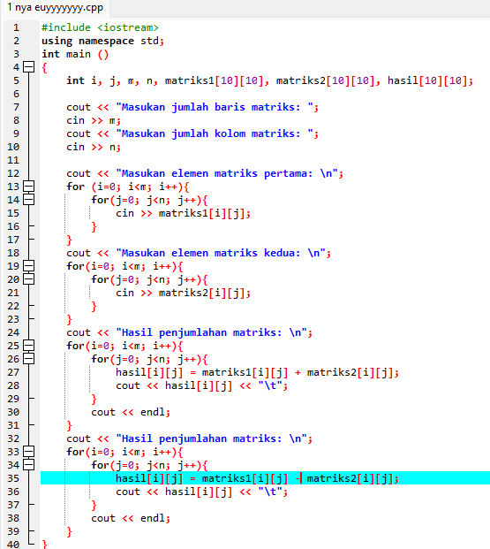

**Screenshoot OUTPUT halaman 119 nomor 2**

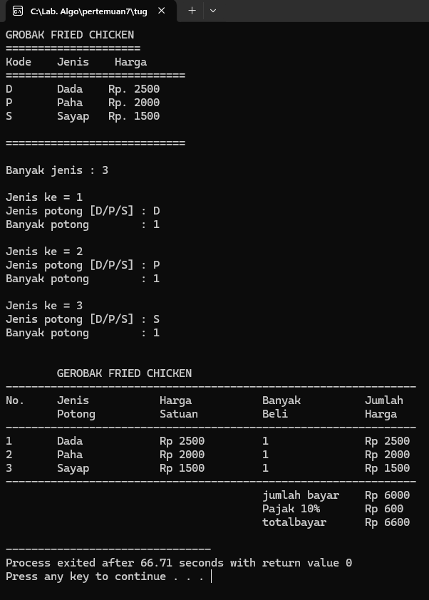

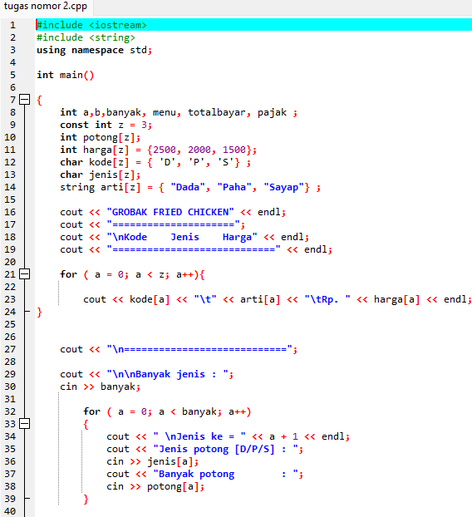**Screenshoot CODING halaman 119 nomor 2**

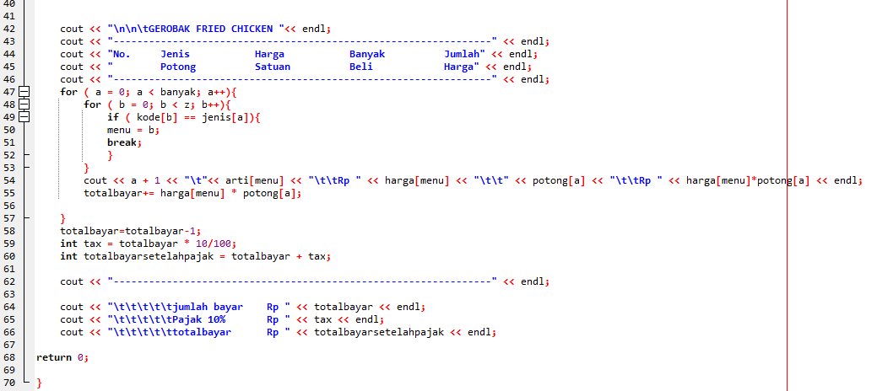

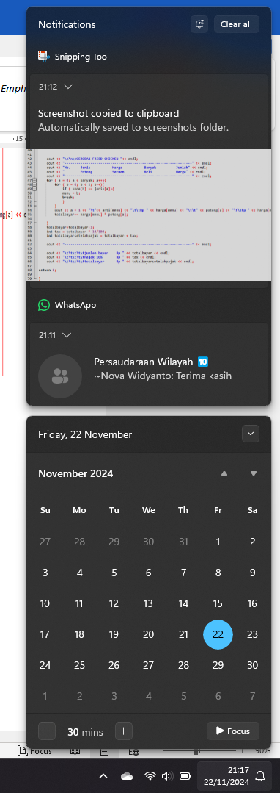**Screenshoot WAKTU**